**Interoperability Plan for Munson Medical Center’s Neonatal Intensive Care Unit**

***Final Project - SAT 5131***

**Kameron Chung, Brandon Gambrall, Eric Vertin, and Kacey Whisler**



Primary Stakeholders:

1. Dr. Allred, Chief Medical Information Officer Munson Medical Center and Attending, Neonatal Intensive Care Unit

1. Neonatal Intensive Care Unit (NICU) Staff, Munson Medical Center

Objectives/Goals:

1. Define the current state of health information exchange for patients (mom and baby) transferring into the Neonatal ICU at Munson Medical Center. Once defined, assess for gaps and establish specific objectives to increase interoperability.
   1. *See Appendix 1 for flowchart of current transfer process*
2. Create a tiered approach and associated timeline for the NICU that addresses medical record reconciliation for patients that are transferred in from an external health system. Clearly define necessary steps for success and identify the roles and responsibilities for key stakeholders.

Individual Stakeholder Goals/Objectives with Identified ROIs:

1. Dr. Allred:
   1. Identify all available interoperability resources, active and inactive
   2. Begin utilizing interoperability resources
      1. Increased efficiency of data transfer, specifically from mother’s chart and existing chart for transport patients.
      2. Improved continuity of care
2. NICU Staff:
   1. Increase efficiency of data transfer
   2. Education on where to find important patient information from outside facilities/units
      1. Improved patient safety and continuity of care

Barriers/Physical Restrictions to Stakeholder Success:

1. In our discovery period for this project, we have found that while Munson does have access to Commonwell in their system, it is critically underutilized in the NICU. Commonwell is a Qualified Health Information Network that connects different IT systems and care settings. After the implementation of Cerner’s One Patient Record across the Muson healthcare system, Commonwell is active; however, patients are not being automatically enrolled and there is no defined process, policy, or department ownership in the NICU to ensure Commonwell is utilized for healthcare information exchange.
2. Cumbersome format of health information when receiving a patient from outside of the Munson health system. C-CDAs are obtainable in the NICU setting; however, the format is a PDF. Providers are unable to electronically merge information and are using a manual process to input pertinent clinical information into the EMR.
3. Munson Healthcare has an IT Application Change Request Freeze in place for an undetermined amount of time post the system Cerner Go-Live in January 2025. Historically, a similar project to work with MiHIN was submitted and declined.

The project number was 17144 and written as follows, “*Would like to explore the pros/cons of ingesting CCDA files from MiHIN. BCBSM has HIE Initiative for this with dollars / practice attached. BCBSM HIE Initiative - Will pay $6500 / practice for utilization and process of use for MiHIN CCDA. Has Munson ever considered ingesting CCDA data from MiHIN into Cerner”.*

The project was cancelled in February 2025 with the following note attached*: “Triage team met this morning and deemed that this request does not meet criteria to proceed during the freeze. Per IT Leadership the denial letter (email) has been sent to the user and they can resubmit after the freeze has been concluded, and this project will be cancelled.”*

Resolutions/Solutions:

A tiered approach will be created to provide solutions focused on improving the flow of healthcare information into the Neonatal Intensive Care Unit. Once the NICU has applied the associated solutions, the intent will be to implement best practices with other service lines within the acute care system.

Due to the constraints with IT requests, the first phase will focus on the use of Commonwell. The second phase will focus on establishing a relationship with Michigan Health Information Network Shared Services (MiHIN).

**Phase I: Implement Commonwell**

1. **EHR Vendor Integration** 
   1. Confirm vendor support: First, ensure the EHR vendor used by the health system is a CommonWell-enabled partner
   2. Enable functionality: The health system works with the EHR vendor to activate the CommonWell services—this may require configuration or an update.
2. **Sign Participation Agreements**

To join CommonWell, the health system must:

* 1. Sign membership agreements with the CommonWell Health Alliance.
  2. Agree to privacy, security, and data-sharing policies.
  3. Some agreements may be facilitated by the EHR vendor if CommonWell services are embedded.

1. **Technical Onboarding**

The health system will go through a technical onboarding process, which includes:

* 1. Identity management setup: Using a master patient index (MPI) to ensure accurate patient matching across systems.
  2. Record locator services (RLS): Configuring the ability to find where a patient’s records are stored.
  3. Data exchange endpoints: Setting up the secure API connections (often HL7 FHIR or IHE standards).
  4. Testing: The EHR vendor and CommonWell support testing to verify that connections and data exchange are working correctly.

1. **Workflow Integration**

The health system integrates CommonWell access into the clinical workflow:

* 1. Clinicians can search for and retrieve patient records from other providers.
  2. Patient consent is managed within the workflow (opt-in or opt-out, depending on state laws and policies).
  3. Information from CommonWell appears directly within the EHR interface, often tagged or separated for clarity.

1. **Staff Training**

Clinicians, medical records staff, and IT personnel are trained to:

* 1. Use CommonWell functions properly.
  2. Understand how to request external data, resolve patient matching issues, and handle consent.

1. **Go-Live and Ongoing Maintenance**

Once live, the health system begins using CommonWell in practice:

* 1. Monitor usage and troubleshoot any issues.
  2. Stay current with CommonWell updates, standards (like FHIR evolution), and policy changes.
  3. May expand to include care partners, imaging centers, or other external providers over time.

**Phase II: MiHIN**

1. **MIHIN Integration Preparation**
   1. Review MIHIN:
      1. Ensure that Munson is active within MiHIN
   2. Templates:
      1. Look for or create:
         1. HIE Participation Agreement Template: This template should include terms for securely sharing electronic health records (EHRs) through MIHIN and meeting MIHIN’s security and interoperability standards.
         2. Data Sharing Agreement: This will include agreements on how patient data will be shared with other providers through MIHIN.
         3. BCBS P4P Performance Metrics Template: A template that outlines the BCBS P4P performance criteria that Munson will need to meet and report on to validate reimbursement.
2. **Contract Group and Legal Requirements**
   1. Review and Update Contracts:
      1. MIHIN Contract Template: Ensure that Munson’s participation in MIHIN is documented in the Contract Group with a clear agreement on sharing health information securely.
      2. Data Access and Confidentiality: Legal team should review data access clauses to ensure patient confidentiality and HIPAA compliance.
      3. P4P Reimbursement Clauses: Work with BCBS to ensure that the contract outlines reimbursement terms based on meeting P4P quality metrics, with clauses for performance validation.
      4. Review and Align with BCBS Reimbursement Terms:
3. **IT and HIM Team Engagement for Data Integration**
   1. IT Integration:
      1. Integrate EHR with MIHIN: The IT team should ensure Munson’s EHR system (e.g., Cerner) is compatible with MIHIN. Develop integration paths to share real-time patient data with other healthcare providers, enhancing care coordination. Munson must demonstrate patient-to-provider relationships through an Active Care Relationship Service (ACRS) file.
      2. Secure Data Transmission: Ensure that all data exchanged via MIHIN is encrypted, meeting security standards and HIPAA requirements to protect patient confidentiality.
      3. Data Interoperability Testing: Confirm that C-CDA structure matches the specifications defined by MIHIN’s implementation guide.
   2. HIM Compliance:
      1. Ensure that all data shared via MIHIN adheres to HIM standards, including patient consent management and accurate coding practices.
      2. HIM teams should verify that data exchanged is accurate, complete, and up to date for BCBS P4P reporting.
4. **BCBS Reports for P4P Reimbursement Validation**
   1. Establish BCBS Reporting Protocols:
      1. Work with BCBS to establish clear guidelines on how P4P metrics will be validated using MIHIN data, including identifying the specific clinical outcomes that will be tracked.
   2. Data Collection and Report Generation:
      1. Automation: Implement automated data collection from MIHIN to generate BCBS P4P reports. This includes pulling data on patient outcomes, readmission rates, preventive care completions, and other metrics.
      2. Quarterly Review: Ensure that the BCBS reports are reviewed quarterly to monitor performance against P4P metrics and identify areas for improvement.
   3. Validate Quality Metrics:
      1. Use the MIHIN data to validate that Munson is meeting the P4P benchmarks for patient care quality. This data will serve as the foundation for BCBS reimbursement calculations.
      2. Work closely with BCBS’s contract manager to ensure timely submission of reports and review performance.
5. **Monitor, Evaluate, and Adjust**
   1. Continuous Improvement:
      1. Establish a performance review committee that includes representatives from IT, HIM, Revenue Cycle, and Clinical teams. This committee will monitor Munson’s performance against P4P metrics and MIHIN participation status.
      2. Analyze quarterly reports from MIHIN and BCBS to track progress and identify areas for improvement (e.g., chronic disease management, care coordination).
   2. Education and Training:
      1. Provide ongoing training for staff on best practices for data sharing through MIHIN, improving care coordination across departments, and ensuring that the quality metrics are integrated into daily workflows.
      2. Educate clinical staff about the impact of their work on BCBS P4P reimbursements, emphasizing how high-quality care leads to better financial outcomes for the hospital.
6. **Final Review and Adjustments**
   1. Internal Audit:
      1. Conduct a semi-annual audit of Munson’s MIHIN data exchange activities and BCBS P4P performance. Use these findings to make adjustments and further optimize workflows.
      2. Adjust the implementation plan as needed based on audit results and feedback from stakeholders.
   2. Feedback Loop with BCBS and MIHIN:
      1. Regularly communicate with BCBS and MIHIN to ensure that Munson is meeting expectations for data exchange, performance metrics, and reimbursement.

Appendices:

1. Current workflow for receiving a patient transfer to Munson NICU

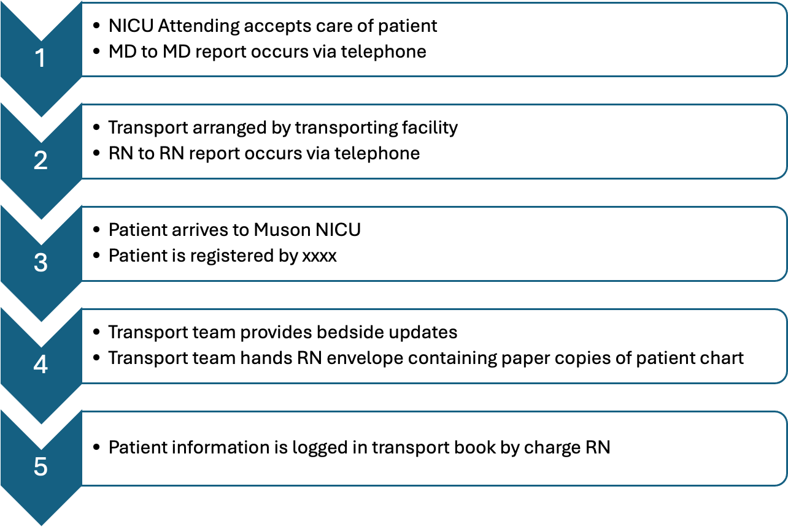

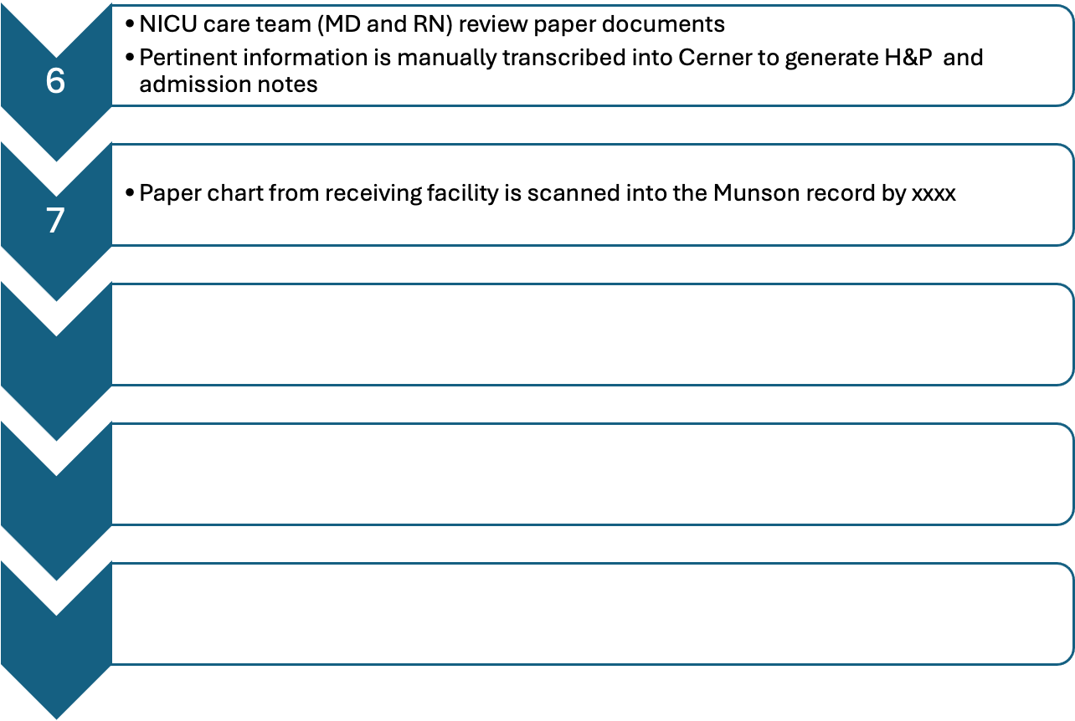

**References**

Integrating the Healthcare Enterprise (IHE). (2011, September 9). *IHE patient care coordination (PCC)*

*technical framework supplement: newborn discharge summary (NDS) trial implementation.* https://www.ihe.net/Technical_Framework/upload/IHE_PCC_Suppl_NDS_Rev1-2_TI_2011-09-09.pdf

Kaplan, H. C., Edwards, E. M., Soll, R. F., Morrow, K. A., Meyers, J., Timpson, W., Cohen, H., Fry, M.,

Schierholz, E., Buus-Frank, M. E., & Horbar, J. D. (2020). Variability in the systems of care supporting critical neonatal intensive care unit transitions. *Journal of Perinatology : Official Journal of the California Perinatal Association*, *40*(10), 1546–1553. <https://doi.org/10.1038/s41372-020-0720-3>

“Migateway.” *MiHIN*, 14 Nov. 2024, mihin.org/migateway/.

Oracle Health. “Overview of Commonwell Enrollment.” *Cerner Wiki,* Mar. 2025, [wiki.cerner.com/display/commonwellHP/Overview+of+CommonWell+Enrollment](http://wiki.cerner.com/display/commonwellHP/Overview+of+CommonWell+Enrollment).

Patel, S. Y., Palma, J. P., Hoffman, J. M., & Lehmann, C. U. (2024). Neonatal informatics: past, present

and future. *Journal of Perinatology : Official Journal of the California Perinatal Association*, *44*(6), 773–776. https://doi.org/10.1038/s41372-024-01924-4

Peacock J. J. (2014). Discharge summary for medically complex infants transitioning to primary care.

*Neonatal Network : NN*, *33*(4), 204–207. https://doi.org/10.1891/0730-0832.33.4.204

“Who We Are V22.” *MiHIN*, 14 Feb. 2025, mihin.org/who-we-are-v22/.